**A Project Report**

##### on

**Brain Tumour Classification and Detection**

##### submitted as partial fulfilment for the award of

BACHELOR OF TECHNOLOGY

**DEGREE**

###### SESSION 2022-23

###### in

**INFORMATION TECHNOLOGY**

##### By

##### Abhijay Krishna (1900290130003)

##### Divya (1900290130058)

##### Chirag Varshney (1900290130052)

**Under the supervision of**

##### Prof. Amar Singh



## Affiliated to

**Dr. A.P.J. Abdul Kalam Technical University, Lucknow**

## (Formerly UPTU)

**May, 2023**

# DECLARATION

##### We hereby declare that this submission is our own work and that, to the best of our knowledge and belief, it contains no material previously published or written by another person nor material which to a substantial extent has been accepted for the award of any other degree or diploma of the university or other institute of higher learning, except where due acknowledgment has been made in the text.

##### Signature

##### Name: Abhijay Krishna Roll No.: 1900290130003

##### Date: 26/12/2022

##### Signature Name: Divya

##### Roll No.: 1900290130058

##### Date: 26/12/2022

##### Signature

##### Name: Chirag Varshney Roll No.: 1900290130052

##### Date: 26/12/2022

# CERTIFICATE

##### This is to certify that Project Report entitled “**Brain Tumour Classification and Detection**” which is submitted by **Abhijay Krishna, Divya, Chirag Varshney** in partial fulfilment of the requirement for the award of degree B. Tech. in Department of Information Technology of Dr. A.P.J. Abdul Kalam Technical University, Lucknow is a record of the candidates own work carried out by them under my supervision. The matter embodied in this report is original and has not been submitted for the award of any other degree.

##### Date: 26/12/2022 Prof. Amar Singh

# ACKNOWLEDGEMENT

##### It gives us a great sense of pleasure to present the report of the B. Tech Project undertaken during B. Tech. Final Year. We owe special debt of gratitude to **Prof. Amar Singh**, Department of Information Technology, KIET, Ghaziabad, for her constant support and guidance throughout the course of our work. Her sincerity, thoroughness and perseverance have been a constant source of inspiration for us. It is only her cognizant efforts that our endeavours have seen light of the day.

##### We also take the opportunity to acknowledge the contribution of **Dr. Adesh Kumar Pandey**, Head of the Department of Information Technology, Ghaziabad, for his full support and assistance during the development of the project. We also do not like to miss the opportunity to acknowledge the contribution of all the faculty members of the department for their kind assistance and cooperation during the development of our project.

##### We also do not like to miss the opportunity to acknowledge the contribution of all faculty members, especially faculty/industry person/any person, of the department for their kind assistance and cooperation during the development of our project. Last but not the least, we acknowledge our friends for their contribution in the completion of the project.

##### Date: 26/12/2022 Signature:

##### Name: Abhijay Krishna Roll No.: 1900290130003

##### Signature:

##### Name: Divya

##### Roll No.: 1900290130058

##### Signature:

##### Name: Chirag Varshney Roll No.: 1900290130052

### TABLE OF CONTENTS Page No.

DECLARATION ii

CERTIFICATE iii

ACKNOWLEDGEMENT iv

INTRODUCTION vi

LITERATURE REVIEW viii

DATASET ix

COMPARITIVE ANALYSIS… xi

IMPLEMENTATION & OUTCOME xxii

CONCLUSION xxv

REFERENCES xxvi

# INTRODUCTION

##### Machine learning and computer vision have led to advances in several fields, including healthcare, robotics, and self-driving cars. The field of anomaly detection is also being explored by academics for its potential in the biomedical field.

##### A brain tumour is one of the deadliest diseases in the globe due to its expanding effect and fatality rate across all age groups. It is said to be India's second largest cause of cancer. According to the American Cancer Society's most current publication, "Cancer Statistics 2020," approximately 24000 people will develop brain tumours while an estimated 19000 Americans will pass away. Due to increased usage of technology like mobile phones, tablets, and other devices, this condition is now becoming equally common among children. Since the brain has a complicated structure and there are currently over 120 different types of tumours, their appearance in various shapes and sizes makes diagnosis more challenging. For many years, many medical imaging modalities, such as positron emission tomography (PET scan), computed tomography (CT scan), magnetoencephalography (MEG), and magnetic resonance imaging (MRI), have been used to identify brain anomalies. MRI multimodality imaging technology is the most widely used and effective method for diagnosing brain tumours due to its ability to distinguish between structure and tissue based on contrast levels. Most MRI abnormality detection is currently manual, and doctors must expend considerable effort in locating and segmenting the tumour for surgical and therapeutic purposes. This manual method is also prone to errors and may endanger people's lives. Computer-based tumour identification and segmentation studies have begun to concentrate on various machine learning and Deep Learning strategies to address these problems.

##### Early diagnosis of brain tumours aids radiologists in providing an accurate prognosis and increases the likelihood of long-term survival. A lot of effort has already been done in this field to help researchers, clinicians, and patients. While deep models experience the gradient vanishing problem, hybrid models do not have interoperability. The standardization of data pre-processing is also inadequate.

##### To build a bridge across various methodologies, algorithms, and domains, deep learning optimization algorithms are necessary. The main problem with deep learning is how much labelled data it needs to function. Only by doing an exhaustive review of the procedures already in use that is described in the literature will the answer to these issues be discovered. Reviews not only offer you an idea of the benefits and drawbacks, but they also provide you with an idea of a brand-new algorithm or architecture that can be created to address the current issue, and that is the main goal of this paper.

##### In this study, recent studies from between 2015 and 2020 that dealt with identifying and classifying brain tumours using deep learning were taken into consideration. We wanted to investigate the most recent, cutting-edge studies on the identification and categorization of brain tumours.

##### We searched the pertinent papers using Medline, Google Scholar, IEEE Explore, ResearchGate and, ScienceDirect. Every time, the year (2015 to 2020) filter option was chosen, ensuring that only publications from the chosen time period were displayed. The phrases "recognition of MRI pictures using deep learning" and "classification of brain tumour from MRI images" were the most often used.

##### The topic of applying deep learning to identify brain tumours, classify them, or both is covered in all studies. Even though machine learning is a vast field that encompasses deep learning, due to the vast number of studies that have previously been published in that field, research employing machine learning models has not yet been included in this study. In the future, we are certain that the researchers working on the unification of brain tumour detection and classification will benefit from our review.

##### The overarching goal of conducting this thorough survey is to provide researchers with an understanding of what has already been done in the field of brain MRI image classification, including the advantages and disadvantages of previously proposed approaches and Deep Learning algorithms. It also offers some fundamental explanations of brain tumours and the use of MRI in the detection of brain cancers. In the style of a literature review, the second section describes how current approaches and algorithms are being used to create CAD systems.

# LITERATURE REVIEW

##### This part provides an overview of research articles that deal with brain tumour MRI image classification using deep learning algorithms. Section B contains a Table that describes the popular datasets used in the research papers under consideration. This section provides a brief overview of the quantitative literature on brain tumour classification using deep learning over the last six years. The critical analysis of a text is a table that organization and presents the different topics and analyses in a way that is easy to understand.

##### This part provides an overview of research articles that deal with brain tumour MRI image classification using deep learning algorithms. Section B contains a Table that describes the popular datasets used in the research papers under consideration. This section provides a brief overview of the quantitative literature on brain tumour classification using deep learning over the last six years. The critical analysis of a text is a table that organization and presents the different topics and analyses in a way that is easy to understand.

##### Modern methods for classifying brain MRI images now in use adhere to a set of pre-established procedures. The primary steps taken to identify and categorize tumour- and non-tumour-related tissues in brain MRI data.

##### The following is a basic summary of the potential actions and strategies:

##### • Input Images: MRI brain scans are the main input images used. The architecture and memory constraints can determine whether the input is 2D or 3D.

##### • Pre-processing: In modern models, it is one of the key phases that is frequently followed in the literature. Due to its effectiveness in significantly improving the input images, it has emerged as being just as important as any other phase.

##### • Segmentation: This process mainly divides the input image into pieces based on similarities so that only the most important information may be kept and the rest is discarded. While some researchers segment the specific tumour, others segment the area of the image where the tumour is located. There are various methods.

##### • Classification: The goal of classification is to divide the input data into several groups based on behaviours that are common to each group.

##### For training purposes, a CAD system based on deep learning needs a lot of data. There are enough datasets accessible in this area for research purposes. The names of a few of the datasets are briefly listed in Table 2. The study discussed in this paper has used all these datasets, however the BRATS dataset has been the most frequently used because of its scale and superior visualization capabilities.

# DATASET

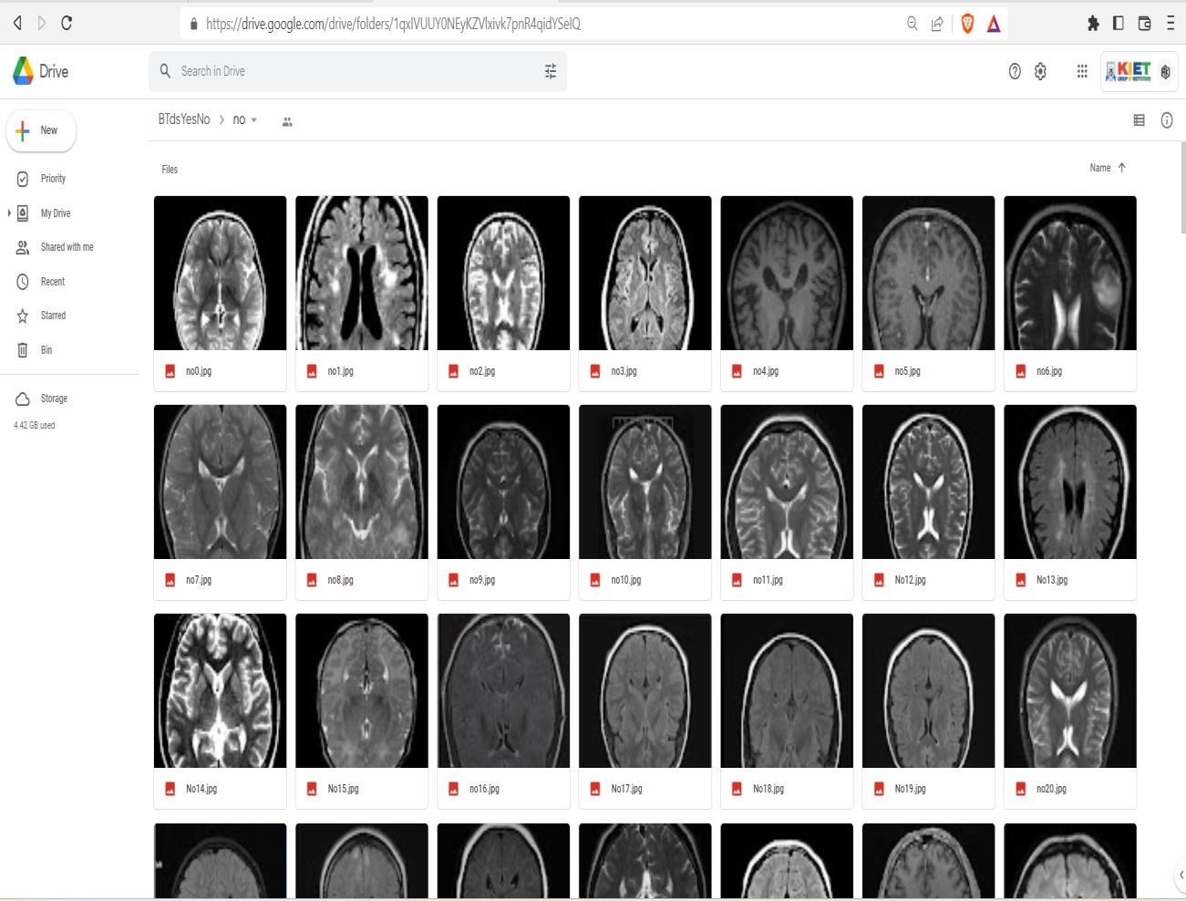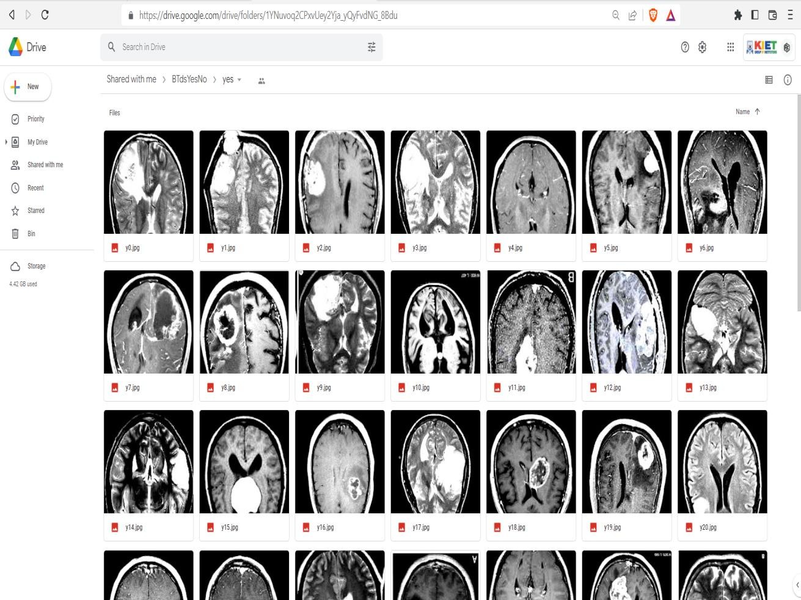

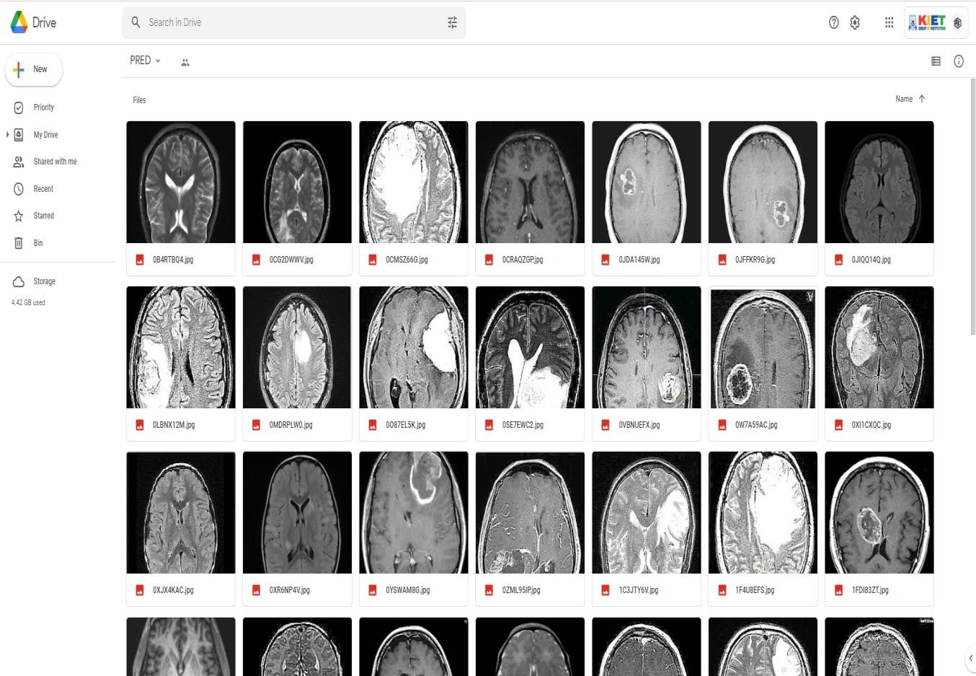

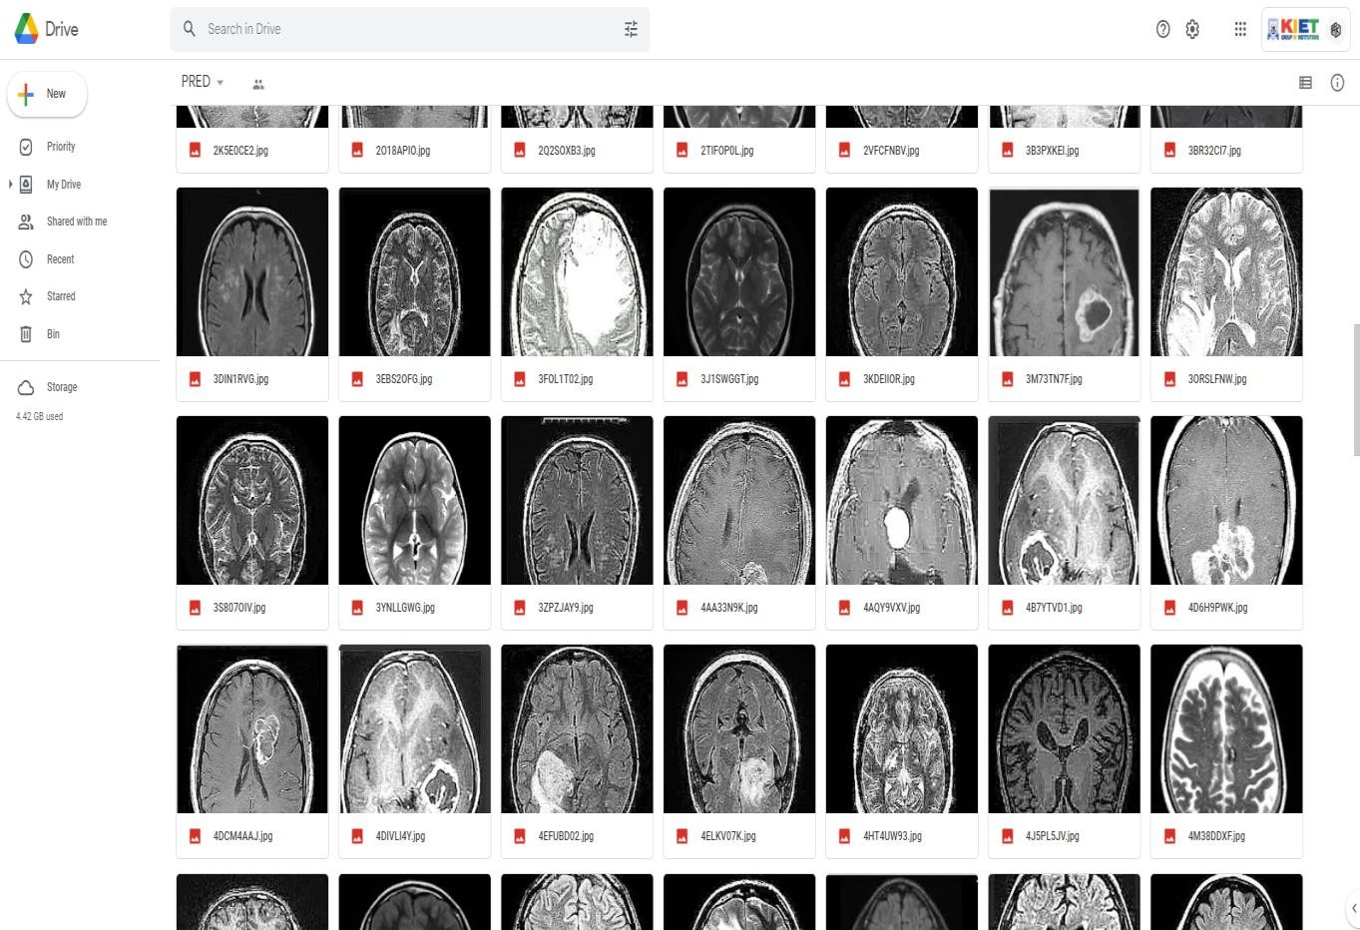

#### Dataset Links

**Training Data -** https://drive.google.com/drive/folders/1q1IgU5PeRow91Ue0A2LcVvRpDPWFKXNl

**Prediction Data -** <https://drive.google.com/drive/folders/1hhB63973hWXwitZkYsFe_fTVXHeOiN9Z>

# COMPARITIVE ANALYSIS

|  |  |  |  |  |  |  |  |  |  |  |  |
| --- | --- | --- | --- | --- | --- | --- | --- | --- | --- | --- | --- |
| Sr  . N  o. | **Re f.** | **Ye ar** | **Purpose** | **Dataset** | **Imagi ng Moda lity** | **Algo** | **Perform ance Metrics** | **Findings** | **Draw Back** | **Features Extracte d** | **Tools/ Softwar e used** |
| 1. | [5  0] | 20  20 | Classify  +  Detect | BRATS 2013,  Whole Brain Atlas (WBA) (8  volumes) | No info | CNN  Models | Accurac y, False alarm and Missed alarm | 96-99%  of all Models yields satisfact ory results | No information about data preprocessing. Best resuts received by Complex model. | CNN | Keras and Tensorfl ow in Python |
| 2. | [5  1] | 20  20 | Classify | Figshare (3,064  images from 233 patients) | T1-  wCE | Capsule Net | Accurac y, Precision  , recall and F1 score | W/O pre-p  87% and With pre-p 92% | Training time not provided, shallow architecture. | CNN | TensorF low |
| 3. | [5  2] | 20  20 | Classify into tumor and non- tumor | Dataset by Chakrab orty, 2019  from Kaggle (155  tumor and 98  normal images) | No info shared | CNN/SV  M for classifica tion | Accurac y, sensitivit y, specificit y and F1 score | Accurac y was found to be 96.77% | Hard and time- consuming method used for feature enhancement and selection | Alexnet and VGG16  are used for feature extractio n and RFE is used for  feature selection | Matlab |
| 4. | [5  3] | 20  20 | Classify into tumor and non- tumor | BRATS 2015 | T1c, T1,  T2,  Flair | Deep Autoenc oder with SoftMax regressio n. | Accurac y | High classifica tion accuracy (98.5 %) | Complexity of feature extraction | Bayesian clusterin g for segmenta tion and scatterin g Transfor m | Matlb |
| 5. | [5  4] | 20  20 | Classify into tumor and non- tumor | BRATs 2012,  2013,  2014,  2015 | T1c, T1,  T2,  Flair | Stacked Sparse Autoenc oder | Accurac y, sensitivit y, specificit y | Improve d average accuracy of 98% in all dataset. | Shallow architecture of SSAE. No  improvement in accuracy & computation time | Stacked Sparse Autoenc oder (SSAE) | Matlab |

|  |  |  |  |  |  |  |  |  |  |  |  |
| --- | --- | --- | --- | --- | --- | --- | --- | --- | --- | --- | --- |
| 6. | [5  5] | 20  20 | Classify into tumor and non- tumor | Brain tumor detection dataset from Kaggle (2  folders) | No info shared | Resnt50 as baseline network | Accurac y, sensitivit y, specificit y, precision  ,  recall | The increase in accuracy to 97% | Complex architecture becoz of new 8 layers. Lame approach | CNN,  Resnet50  ,  Alexnet, Googlen et | Matlab |
| 7. | [5  6] | 20  20 | Detect tumor and non - tumor images | Kaggle (Dataset made by Chakrab orty) | No info | Brain MRNET (CBAM,  residual blocks and hyper column techniqu  e) | Accurac y, sensitivit y, specificit y | Brain MRNET  model is having 96%  accuracy | Complex Architecture | Brain- MRNET (CNN) | Matlab |
| 8. | [5  7] | 20  20 | Classify into 3 types | Figshare (3064  images) | T1c | Residual networks | Accurac y, precision  , recall, F1- score and balanced accuracy  . | Achieve d highest accuracy of 99% | No originality.  Increased parameters due to Augmentation | Resnet50 | Python 3.6,  using Keras library with Tensor Flow |
| 9. | [5  8] | 20  20 | Tumor and non- tumor | BRATS 2012  2013,  2015,  2018 | T1-  CE,  T1, T2  Flair | DWT-  for feature fusion CNN  for classific ation | Accur acy, sensiti vity, specifi city | Improve d accuracy  ,  sensitivit y on each dataset | Complex due to increase in number of parameters.  Satisfactory accuracy in case of fused images. | CNN | Didn’t Mention |
| 10  . | [5  9] | 20  20 | Classify into three types | Figshare (3064  images from 233 patients) images from 150 subjects) | T1- CE | CNN- GAN | Accurac y, precision  ,  sensitivit y, F1  score | 88%  Accurac y | Complex method. No differences | CNN - GAN | Keras with Python |

|  |  |  |  |  |  |  |  |  |  |  |  |
| --- | --- | --- | --- | --- | --- | --- | --- | --- | --- | --- | --- |
| 11  . | [6  0] | 20  20 | Detect+ classify into benign and malignant | Cancer genome atlas glioblast o ma multifor m (TCGA- GBM)  and database in the cancer imaging archive (TCIA) (500  samples) | T1- GD  enhan ced MRI  image s | CNN for segmenta tion and features | Accurac y | 98.33 % | Complex and lengthy method | CNN  (squeeze  - net) Segment ed using SR-FCM | Didn’t mention |
| 12  . | [6  1] | 20  20 | Detect + Classify | Figshare by Cheng | T1- CE | F- RCNN  and region proposal uses VGG-16  as the base network | Precision | Average precision of 75.18%  for glioma, 89.45%  for meningi oma and 68.18%  for pituitary tumor. | Testing time not mentioned. Complexity of region proposal network | F-RCNN | Did’ not mention |
| 13  . | [6  2] | 20  20 | Classificatio n | BRATS, CE-MRI | Flair image s from BRA TS  and T1C  from CE- MRI | Block- wise fine tuning and transfer learning on VGGnet and KNN as classifier | Sensitivit y, specificit y, precision  , F1-  Score | 97.28%  accuracy on the BTDS-2  and and 98.69%  on CE- MRI  datasets respectiv ely. | Complex structure, No information of training and testing time is shown | Deep VGGnet | Didn’t mention |
| 14  . | [6  3] | 20  20 | Classify + Detect | Kaggle | No info shared | CNN | Accurac y | 90 to  99%  Accurac y | No information of CNN  architecture. No instinct of pre- processing.  Training and testing time not shared. | CNN (GUI  was also designed  ) | Tensor flow and python |

|  |  |  |  |  |  |  |  |  |  |  |  |
| --- | --- | --- | --- | --- | --- | --- | --- | --- | --- | --- | --- |
| 15  . | [6  4] | 20  20 | Detect and classify as cancerous or non- cancerous | Harvard medical school (128  images with multiple brain tumors) | No info shared | Segment ation using threshold ing and then classifica tion using KSVM | Accurac y, precision  , recall | 97.4%  accuracy overall | No information regarding CNN  architecture.  No information regarding training testing time, Complexity of prior  segmentation. | CNN | Didn’t mention |
| 16  . | [1  3] | 20  20 | Detection and Classificatio n into three types | Figshare by Cheng (only 170 for each class) | T1- CE | Deep CNN 5  layers | Accurac y, Sensitivit y, specificit y | Accurac y 99.3%  for CNN and 98.5%  for SVM | No comparisons with state of the art method except SVM. Simple CNN model with no ne thing. | Wavelet transfor m | Didn’t mention |
| 17  . | [6  5] | 20  20 | Segmentatio n + Classificatio n | BRATS 13,14,17,  18 | T1,  T2, T1C, FLAI R | Inception V3 pre- trained CNN | Accurac y | 92% for classifica tion | Complexity and time- consuming model.  Increased computational time because of feature fusion. | Using SBDL  for segmenta tion.  Deep Feature extractio n using Inception V3 and selected  using PSO | Matlab 2018b |
| 18  . | [6  6] | 20  20 | Detect + Classify | Private and publicly available dataset (Total 1000  images used) | No info given | RNN | Accurac y, specificit y, sensitvit y | 96%  classifica tion accuracy  , 98%  specificit y, 97%  sensitivit y | No detailed info about the imaging modalities given | Feature extractio n using wavelet statistical approach and selected using oppositio nal gravitati onal search algorith m  (OGSA) | Matlab version (7.12) |

|  |  |  |  |  |  |  |  |  |  |  |  |
| --- | --- | --- | --- | --- | --- | --- | --- | --- | --- | --- | --- |
| 19  . | [6  7] | 20  20 | Detection of tumor/nontu mor images | BRATS 2016 | T1c-  brain axial MRI  image s | PG- GANs  for DA and Resnet- 50 for detection | Accurac y, sensitivit y, specificit y | 91%  accuracy  , 86%  sensitivit y, 97%  specificit y | Further comparisons can be made with state of the art method. No info of training and testing time. | Resnet- 50 | Didn’t mention |
| 20  . | [6  8] | 20  20 | Detect and Classify | OASIS,  Figshare (total of 4689 for detection and 613 for classifica tion) | T1c | 2  BRAIN  NETs for detect and Classific ation | Accurac y, sensitivit y, specificit y | 98%  accuracy for detection and 99% for classifica tion in case of BRAINn  et | No info regarding testing and training time, Complex 22- layer architecture | No, Brainnet | Matlab 2018b. |
| 21  . | [6  9] | 20  20 | Classify | Kaggle, TCIA | 1000  axial MRI  image s | CNN | Accurac y, loss and executio n time | RMSpro p is the best optimize r with 98%  accuracy and fast  executio n. | No comparisons with state-of the art method. Cannot work with 3D MRI | Segment ed using threshold ing and Feature extractio n using CNN | Python using Keras and Tensor Flow |
| 22  . | [7  0] | 20  19 | Classify | Kaggle (tumor, non- tumor images), TCIA | 1000  axial MRI  image s | Seg using PNN  while classifica tion using  CNN | Accurac y | Accurac y greater than 90% for  3  different optimize  rs | No comparisons with state of the art technique | CNN | Python using Keras and Tensor Flow |
| 23  . | [7  1] | 20  19 | Classificatio n | Figshare by cheng (3064  images) | T1- CE | CNN  Convcap s | Accurac y | Classific ation accuracy increases to 93.5%,  and the training speed is also  improve d. | Complex architecture with high number of parameters. | Convcap s | TensorF low |

|  |  |  |  |  |  |  |  |  |  |  |  |
| --- | --- | --- | --- | --- | --- | --- | --- | --- | --- | --- | --- |
| 24  . | [7  2] | 20  19 | Classificatio n | Figshare by cheng (3064  images) | T1- CE | Global Average Pooling Residual Network (G-  RESnet) | Accurac y | 95% | Deep and complex architecture, No listing of training and testing time. | Resnet34 | Pytorch frame work |
| 25  . | [7  3] | 20  19 | Detect (benign/mali gnant) + segmentatio n | Miccai BRATS (2013-  2017) ISLES  strokes dataset | Flair, T1,  T1- CE  and T2 DWI, CBV  and CBF | Threshol ding for segmenta tion Alex and Google net for Feature fusion | Dice, sensitivit y, specificit y, accuracy  , AUC  curve | 99%  accuracy in the case of BRATS 2017  dataset using fusion architect ure | Complex architecture of feature fusion. Not much difference in accuracy using score level fusion. | Feature extractio n using Alexnet and Google net | Matlab |
| 26  . | [7  4] | 20  19 | Detect | 20  patient’s data were used for training | No info shared | Faster R- CNN and SVM | Accurac y | 95% on private dataset | No dataset information. No clear methodology.  Training data was very small | Faster R- CNN.  For convertin g convoluti onal feature map into region proposal  s | Tensorfl ow with python |
| 27  . | [7  5] | 20  19 | Detect + classify into three classes | Figshare dataset (3064  images) | T1- CE | Enhance d SoftMax and loss function with ELM- LRF  CNN | Accurac y, training time, training loss | 97%  accuracy is achieved  . | Very little improvement in accuracy and processing time | ELM-  LRF to Extract features | Python  3.6 with keras |
| 28  . | [7  6] | 20  19 | Classify (tumor or non-tumor)  + segment | Private data set of 330 images | No info shared | CNN | Training accuracy  ,  validatio n accuracy | CNN  archives rate of 98%  accuracy with low Complex ity | Ambiguity about the data set. Very brief results | Feature extractio n using CNN  while segmenta tion using global threshold  ing | Didn’t mention |

|  |  |  |  |  |  |  |  |  |  |  |  |
| --- | --- | --- | --- | --- | --- | --- | --- | --- | --- | --- | --- |
| 29  . | [7  7] | 20  19 | Classify into three types.  Also developed GUI | Figshare dataset (3064  images) | T1-w  image s | CNN  (auto- keras) | Accurac y, sensitivit y, specificit y, F1-  score | 96%  accuracy | No comparisons have been made with state of the art models, No confusion matrices have been made. | CNN  (auto- keras) | Keras with python |
| 30  . | [7  8] | 20  19 | Detect + Classify | Figshare dataset (3064  images) | T1- CE | Capsnet (dilated capsule net) | Accurac y | 95%  Accurac y | No significant model. Not enough comparisons and experiments with confusion matrix | CNN  (dilated capsule net) | Pytorch |
| 31  . | [7  9] | 20  19 | Detect (normal+tu mor brain) | Private dataset containin g 153  patients, 1892  images | No info Share d | Alexnet (CNN)  (SoftMa x, RBF  and DT) | Accurac y, sensitivit y, specificit y, precision | SoftMax classifier has the best accuracy in the CNN of 99% | No clear methodology, No comparisons have been made with state of the art approaches. | Features extractio n using center clusterin g algorith m | Didn’t mention |
| 32  . | [8  0] | 20  19 | Detect (tumor/non- tumor) | BRATS 2016 | T1- CE | PG- GANs  for data augment ation and RESnet- 50 for detection | Accurac y, sensitivit y, specificit y | 87%  accuracy with PG- GAN, 92%  with MUNIT  and 94% with  SIMGA N | Very complex and time- consuming method. No literature reviews provided | GANs | Didn’t mention |
| 33  . | [8  1] | 20  19 | Detection | Miccai BRATS 2018 | Flair, T1, T1-C  and T2. | 3D-Multi CNNs | Dice correlati on coeficien t, sensitivit y, and specificit y. | Dice correlati on coefficie nt 84%, Sensitivi ty 82%, Specifici ty 99% | Not enough literature review. Not enough experimental results were carried out. | 3D  Multi- CNNs | Didn’t mention |

|  |  |  |  |  |  |  |  |  |  |  |  |
| --- | --- | --- | --- | --- | --- | --- | --- | --- | --- | --- | --- |
| 34  . | [8  2] | 20  19 | Detect + class ify into four types | Figshare dataset (3064  images) and 422 images of private datasets of normal, gliomas, meningio mas and metastati c brain tumors | T1-C  and T1,  T2 ,  Flair | DENSEn  et- LSTM, DENSEn  et- DENSEn  et, DENSE  net-RNN | Accurac y | 92% for public and 71% for private data.  DENSEn  et- DENSEn  et present the best performa nce for the proprieta ry  dataset. | Takes too much long for auto-encoder like dense-net (feature extraction). | DENSEn  et (auto- encoder) | TensorF low |
| 35  . | [8  3] | 20  19 | Classify into three types of tumor | Figshare dataset (3064  images) | T1- CE | CNN | Accurac y (F1  score), precision  , Recall | Accurac y of 94%,  average precision of 93.33%  and an average  recall of 93% | The model can be compared with more state of the art models. Very brief results. | CNN | Didn’t mention |
| 36  . | [8  4] | 20  19 | Classify into three types of tumor | Figshare dataset (3064  images) | T1- CE | Capsnet (CNN) | Only accuracy | 90.89%  accuracy is achieved | No method of boundary extracting is shared. Less result and comparisons have been done. | Capsnet | Python 2.7,  using Keras library |
| 37  . | [8  5] | 20  19 | Classify + Segmentatio n | Public dataset | No info shared | Alexnet | Accurac y | 100%  accuracy in training and validatio  n. The model  has flexibilit y for modifica tion, able to train  faster etc. | No comparisons with state of the art models. No testing performance.  No performance metrics involved and discussed | Features extracted using curvelet transfor m and GLCM  matrix. Segment ation using K- means | Didn’t mention |

|  |  |  |  |  |  |  |  |  |  |  |  |
| --- | --- | --- | --- | --- | --- | --- | --- | --- | --- | --- | --- |
| 38  . | [8  6] | 20  19 | Classify (Normal, Benign, Malignant) | BRATS 2015 | Flair | Alexnet, VGG-16 | Equal error rate (EER),  false accept ance rate (FAR)  and false Reject ion rate (FRR). | VGG16  gives 98%  accuracy  . | Better results can be achieved using all 4 modalities. | CNN | Didn’t mention but construc ted GUI pytho n |
| 39  . | [8  7] | 20  19 | Classify (3 types) | Figshare Dataset (3064  images) | T1- CE | Pre- trained Googlen et SVM KNN | Accurac y, precision  , recall, F1 score, specificit y. | Googlen et (92%), SVM (97%), KNN (98%) | Training time is still high (1 Hour with best results) | Features extracted using pre- trained Googlen et. | Matlab 2018b |
| 40  . | [8  8] | 20  19 | Classify + Grading | Figshare by Cheng (3064  images) | T1- CE  image s in datase ts | One CNN to classify type of tumor and one CNN for grading. | Sensitivit y, Specifici ty, Accurac y | Accurac y of 96% and 98%. | Complex architecture of 16 layers.  Learning rate is very high. | CNN | Matlab 2018b  and Python |
| 41  . | [8  9] | 20  19 | Classify into 3 types | Figshare dataset (3064  images) | T1- CE | Alexnet, Googlen et and VGGnet using transfer learning (classify with either SoftMax  or SVM) | Sensitivit y, Specifici ty, Precision | The VGG16  architect ure attained highest accuracy of 98.69%. | Complexity of pre- processing, Time- Complexity | CNN for feature extractio n using Transfer learning. | Caffee Library 7 |
| 42  . | [9  0] | 20  18 | Detect into four types of tumor (benign, Malignant, glial and astrocytoma) | 50 brain MRI  images | No info shared | Alexnet is used for classifica tion along with RPN by faster R- CNN | Overall precision  ,  accuracy | End to End gives better result and reduce inference time per image as compare d to 4 stage training. | No comparison has been done with the state of the art approach.  Limited literature review. Software was used for pre- processing of the dataset. | Feature map extractio n using Alexnet as the base network and RPN network.  Used faster RCNN  for training. | Python with keras and tensor flow |

|  |  |  |  |  |  |  |  |  |  |  |  |
| --- | --- | --- | --- | --- | --- | --- | --- | --- | --- | --- | --- |
| 43  . | [9  1] | 20  18 | Detect (tumor and non- tumor) | BRATS  2015 and images from Radioped ia | No info shared | CNN | Validatio n accuracy  , training accuracy | 97.5%  Accurac y | No clear info about the modalities used. No clear methodology.  Not much improved results | Feature were taken from ImageNe t database | Python |
| 44  . | [9  2] | 20  18 | Classify into tumor/non tumor | Rembran dt and ’SPIE- AAPM- CT  Challeng e | Front, coron al, sagitta l views but no info regard ing the  modal ity | CNN  (Alexnet and ZFnet) with 10 layers each | Accurac y | 97%  accuracy in both cases | The network is not able to learn from mixed type of data (axial, coronal, sagittal). No mention of training and testing time. | CNN  (Alexnet and ZFnet) | Didn’t mention |
| 45  . | [9  3] | 20  18 | Classify into normal, benign or malignant images | The 2015  Miccai BRATS  challenge  . | T1,  T2,  Flair, T1- CE | U-Net for segmenta tion and CNN for classifica tion | Nothing mentione d | Not a single result | No specificity results were shared.  Normal tissues were also categorized as tumor tissues (that was a problem).  Vague methodology | U-net was used for feature extractio n and CNN  was used for classifica ton. | Tensor flow and keras |
| 46  . | [9  4] | 20  18 | Segmentatio n + Classificatio n into three types | Harvard dataset (66 real human brain MRIs) | Axial Plane, T2-  weigh ted and 256*2  56  pixel | Deep neural network for classifica tion and fuzzy C- means clusterin g for segmenta  tion. | Accurac y, precision  , recall, F-score, ROC  curve | 98%  Accurac y | No enough literature review, Technique employed was also used many times.  Very small dataset can lead to  overfitting of the model. | Feature extractio n using DWT  and reduced using PCA | Matlab R2015a  and weka 3.9 |

|  |  |  |  |  |  |  |  |  |  |  |  |
| --- | --- | --- | --- | --- | --- | --- | --- | --- | --- | --- | --- |
| 47  . | [9  5] | 20  17 | Classificatio n into benign and malignant (tumor grading) | BRATS 2015 | T1,  T2,  T1- CE  and Flair | 3D CNN  with gated multimo dal units (GMU) | Mean accuracy  ,  sensitivit y, Specifici ty and positive predictiv e value (PPV) | 75.4 % for Flair 74.2%  with 3.3%  improve ment | Not enough literature review. No comparisons with state of the art approach.  Only compared with some changes in itself | GMU  fusion of feature informati on using 3D CNN | Didn’t mention |
| 48  . | [9  6] | 20  17 | Classify and segent tumour | No info | No info | CNN | No info | Classify using CNN  and segment | No results and comparisons. No method discussed. No info about the dataset | CNN | Matlab |
| 49  . | [9  7] | 20  17 | Classify into HG  and LG | BRATS  2017 and TCIA | T1,  T1-  CE,  T2,  Flair | 3 models of convnet (patchnet  , slicenet, volumen et) | Accurac y, F1  score | Testing accuracy of 97% for volumen et. Novel approach | Complexity of the proposed scheme + high training time | Feature extractio n using convoluti onal neural network | TensorF low, with Keras in Python. |
| 50  . | [9  8] | 20  17 | Classify into 4 types of brain tumors | Rembran dt (65427  images of 100 patients). | No info shared Excep t (MRI  scans of axial, coron al and sagitta l planes are  used) | Deep CNN  with 8 layers | F1-score and accuracy | The model performs with an average F1-score of 99.46%. | There is no comparison made with state of the art methodologies  . Also, the approach is not novel. | CNN | TensorF low, TFLear n and other python libraries |

**IMPLEMENTATION AND OUTCOME**

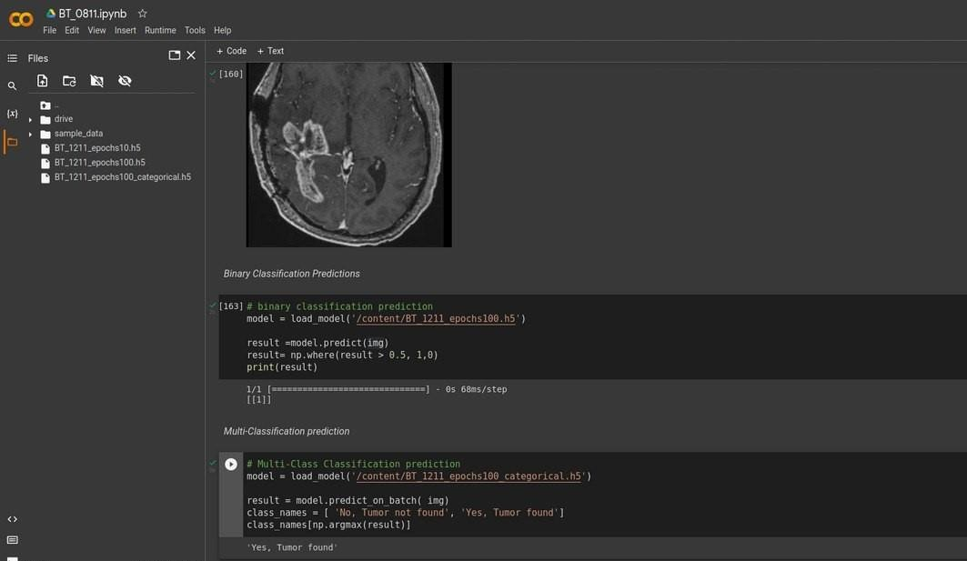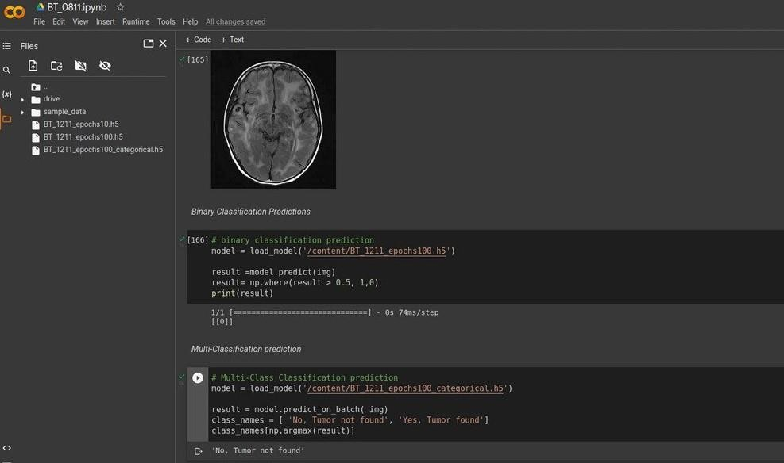

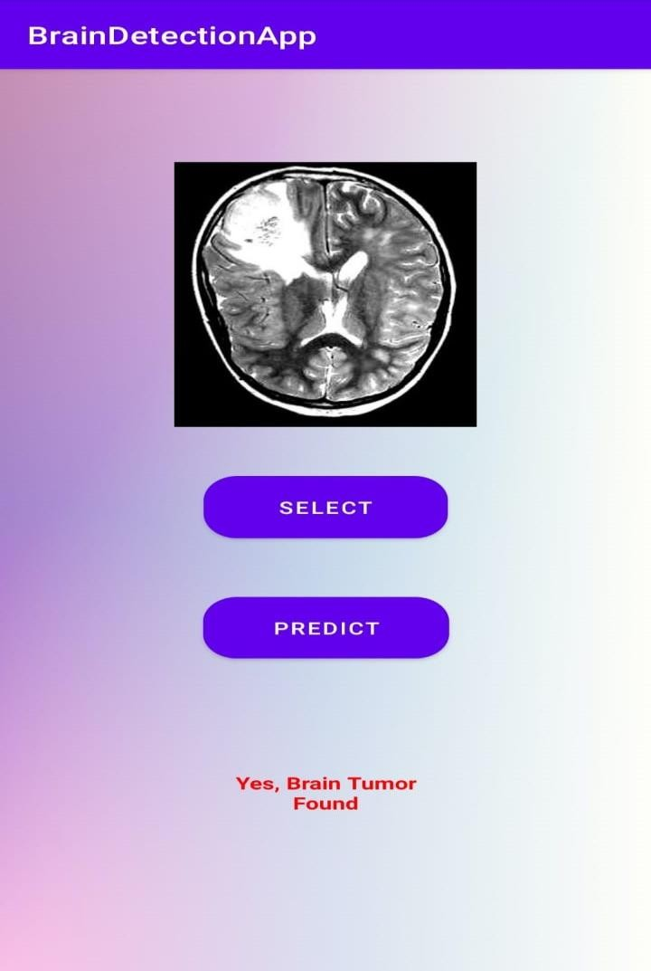

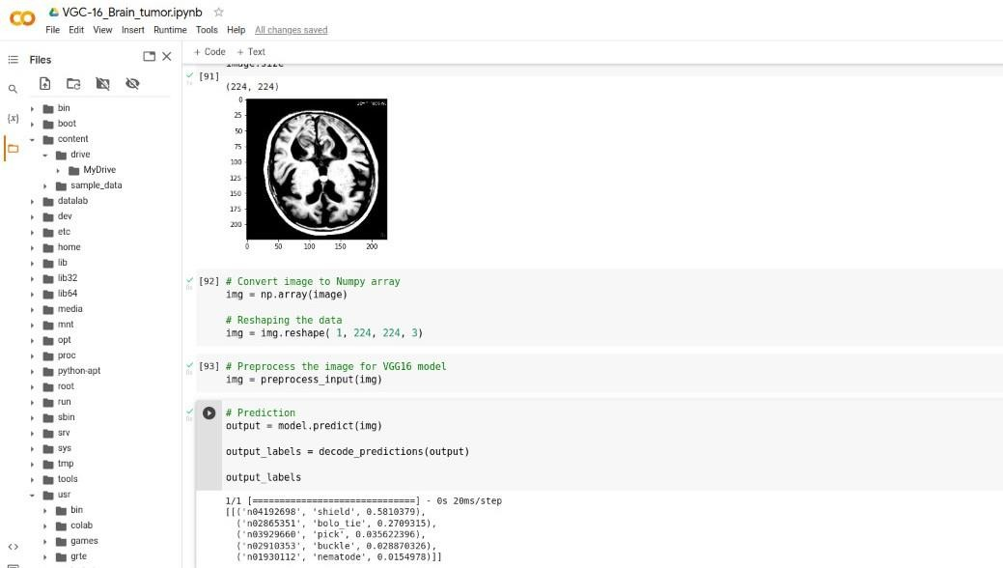

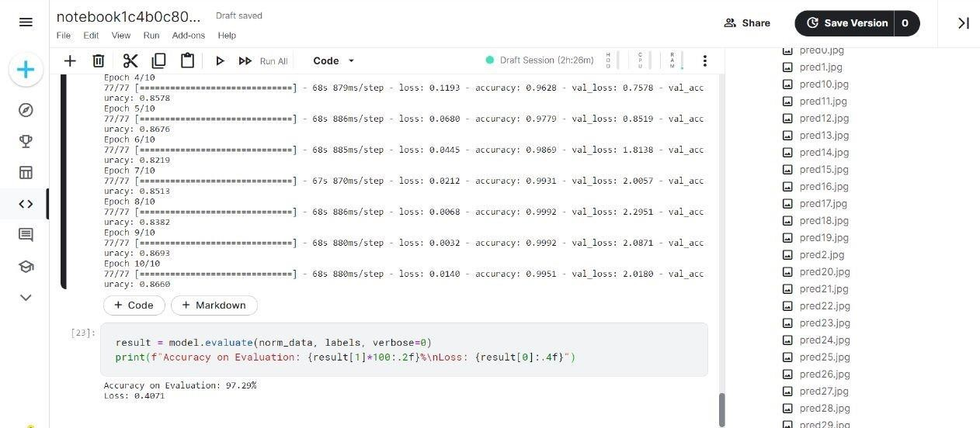

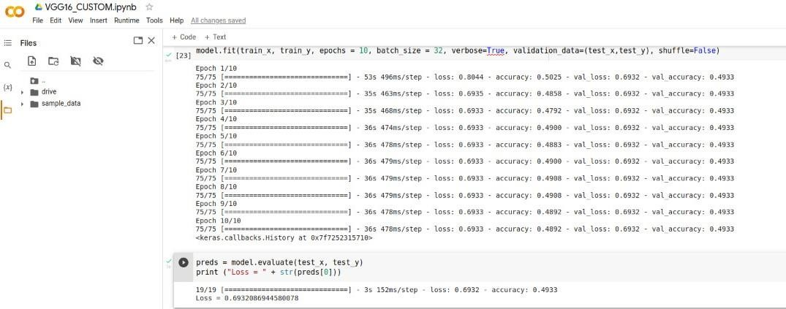

# CONCLUSION

##### This study provides an in-depth analysis of studies published between 2015 and 2020 that used deep learning to identify MRI images of brain tumours and classify them into tumour and non-tumour classes**.** Even though many useful and effective algorithms have been created thus far, the absence of standardization means that each algorithm still has certain shortcomings. In this study, a detailed critical examination of the benefits and drawbacks of each approach that has been proposed is offered. To help future researchers create some optimal CAD systems, various performance-degrading elements and their fixes are also provided. Comparative examination shows that Deep Learning algorithms and approaches are quite powerful and have a high capacity for handling enormous amounts of data. However, the research of brain tumours does not fully take use of their advantages. A completely automated unified framework that can accurately identify and categorize brain tumours into many categories with less complexity is clearly needed, according to the above- mentioned thorough assessment.

##### Bearing in mind the above limitations and difficulties faced by researchers and scientists currently working in this field, some key concepts are provided that can be considered in the development of future models. The key concept is to create a pre-processing system that can perform colour balance on textured MRI images to take advantage of new and improved capabilities. Although tumour classification and segmentation have been the subject of much research, tumour detection has received less attention.

##### The most crucial phase is detection, and it needs to be treated equally in upcoming research and studies. We can only fully utilize the 3D features and hidden information within an MRI picture in this manner. New strategies and techniques must be developed to combine the capabilities of shallow and deep architectures into one cohesive framework.

##### Most crucially, there is not a single totally autonomous method for all jobs. Automating tumour classification and segmentation is one of the main goals of deep learning-based brain tumour investigations, and efforts toward creating such a framework are important. A uniform framework must be created to integrate multiple processes, from pre-processing through the final phases of tumour type detection. In conclusion, there is great hope for the future of deep- learning based brain tumour investigations, and if they are focused in the proper manner, they might be transferred from research laboratories to hospitals. We think that the researchers will get insight from our review on the future avenues to pursue for this goal.

# REFERENCES

1. *M. K. Abd-Ellah, A. I. Awad, A. A. M. Khalaf, and H. F. A. Hamed, ‘A review on brain tumor diagnosis from MRI images: Practical implications, key achievements, and lessons learned’, Magn. Reson. Imaging, vol. 61, no. May, pp. 300–318, Sep. 2019, doi: 10.1016/j.mri.2019.05.028.*
2. *K. R. Bhatele and S. S. Bhadauria, ‘Brain structural disorders detection and classification approaches: a review’, Artif.Intell. Rev., 2019, doi: 10.1007/s10462-019-09766-9.*
3. *D. Nanware, S. Taras, and S. Navale, ‘Brain Tumor Detection Using Deep Learning’, Int. J. Sci. Res. Eng. Dev., vol. 3,pp. 391–395, 2020.*
4. *Muhmmad Irfan Sharif, ‘Recent Advancements in Brain Tumor Segmentation and Classification using Deep Learning: A Review’, Int. J. Eng. Res., vol. V8, no. 12, pp. 319–325, 2019, doi: 10.17577/ijertv8is120190.*
5. *H. Kaur and A. K. Gill, ‘Review of Brain Tumor Detection Using Various Techniques’, Int. J. Adv. Res. Comput. Sci. Softw. Eng., vol. 7, no. 5, pp. 867–870, 2017, doi: 10.23956/ijarcsse/v7i4/0221.*
6. *M. Sharif, J. Amin, M. Raza, M. Yasmin, and S. C. Satapathy, ‘An integrated design of particle swarm optimization (PSO) with fusion of features for detection of brain tumor’, Pattern Recognit. Lett., vol. 129, pp. 150–157, Jan. 2020,doi: 10.1016/j.patrec.2019.11.017.*
7. *M. Jayali, V. Bhagat, and B. Dhaigude, ‘A Survey on Brain tumor Detection Techniques’, Int. Res. J. Eng. Technol., vol.8, no. 4, pp. 28–32, 2017.*
8. *M. I. Sharif, J. P. Li, J. Naz, and I. Rashid, ‘A comprehensive review on multi-organs tumor detection based on machine*

learning’, Pattern Recognit. Lett., vol. 131, pp. 30–37, Mar. 2020, doi: 10.1016/j.patrec.2019.12.006.

1. *B. Panda and C. S. Panda, ‘A Review on Brain Tumor Classification Methodologies’, Int. J. Sci. Res. Sci. Technol., vol.6, no. 6, pp. 346–359, 2019, doi: 10.32628/ijsrst20717.*
2. *R. Kaur and A. Doegar, ‘Localization and Classification of Brain Tumor using Machine Learning &amp; Deep Learning Techniques’, Int. J. Innov. Technol. Explor. Eng., vol. 8, no. 9S, pp. 59–66, Aug. 2019, doi: 10.35940/ijitee.I1010.0789S19.*
3. *M. Nazir, M. A. Khan, T. Saba, and A. Rehman, ‘Brain tumor detection from MRI images using multi- level wavelets’,*

2019 Int. Conf. Comput. Inf. Sci. ICCIS 2019, pp. 1–5, 2019, doi: 10.1109/ICCISci.2019.8716413.

1. *R. L. Siegel, K. D. Miller, and A. Jemal, ‘Cancer statistics, 2020’, CA. Cancer J. Clin., vol. 70, no. 1, pp. 7–30, Jan.2020, doi: 10.3322/caac.21590.*
2. *A. M. Sarhan, ‘Brain Tumor Classification in Magnetic Resonance Images Using Deep Learning and Wavelet Transform’, J. Biomed. Sci. Eng., vol. 13, no. 06, pp. 102–112, 2020, doi: 10.4236/jbise.2020.136010.*
3. *M. Mudda, R. Manjunath, and N. Krishnamurthy, ‘Brain Tumor Classification Using Enhanced Statistical Texture Features’, IETE J. Res., vol. 0, no. 0, pp. 1–12, 2020, doi: 10.1080/03772063.2020.1775501.*
4. *S. A. Swapnil and V. S. Girish, ‘Image Mining Methodology for Detection of Brain Tumor: A Review’, in 2020 Fourth International Conference on Computing Methodologies and Communication (ICCMC), 2020, no. Iccmc, pp. 232–237, doi: 10.1109/ICCMC48092.2020.ICCMC-00044.*
5. *L. Kapoor and S. Thakur, ‘A survey on brain tumor detection using image processing techniques’, in 2017 7th International Conference on Cloud Computing, Data Science & Engineering - Confluence, 2017, pp. 582–585, doi:10.1109/CONFLUENCE.2017.7943218.*
6. *A. R. Deepa and W. R. Sam Emmanuel, ‘A comprehensive review and analysis on mri based brain tumor segmentation’,*

Int. J. Sci. Technol. Res., vol. 8, no. 10, pp. 2140–2154, 2019.

1. *G. S. Tandel et al., ‘A review on a deep learning perspective in brain cancer classification’, Cancers (Basel)., vol. 11, no.1, 2019, doi: 10.3390/cancers11010111.*
2. *N S Zulpe and V P Pawar, ‘Review on Brain Tumor Segmentation and Classification Techniques’, Int. J. Eng. Res., vol.V6, no. 11, pp. 7–11, 2017, doi: 10.17577/ijertv6is110008.*
3. *N. Kumari and S. Saxena, ‘Review of Brain Tumor Segmentation and Classification’, Proc. 2018 Int. Conf. Curr. Trends Towar. Converging Technol. ICCTCT 2018, pp. 1–6, 2018, doi: 10.1109/ICCTCT.2018.8551004.*
4. *M. W. Nadeem et al., ‘Brain tumor analysis empowered with deep learning: A review, taxonomy, and future challenges’,Brain Sci., vol. 10, no. 2, pp. 1–33, 2020, doi: 10.3390/brainsci10020118.*
5. *F. Gao, H. Yoon, T. Wu, and X. Chu, ‘A feature transfer enabled multi-task deep learning model on medical imaging’,*

Expert Syst. Appl., vol. 143, p. 112957, 2020, doi: 10.1016/j.eswa.2019.112957.

1. *J. Liu, M. Li, J. Wang, F. Wu, T. Liu, and Y. Pan, ‘A survey of MRI-based brain tumor segmentation methods’,*

Tsinghua Sci. Technol., vol. 19, no. 6, pp. 578–595, 2014, doi: 10.1109/TST.2014.6961028.

1. *D. S. S. K. Vipin Y. Borole, Sunil S. Nimbhore, ‘Image Processing Techniques for Brain Tumor Detection: A Review’,*

Int. J. Emerg. Trends Technol. Comput. Sci. Web, vol. 4, no. 5, pp. 28–32, 2015.

1. *G. Mohan and M. M. Subashini, ‘MRI based medical image analysis: Survey on brain tumor grade classification’,*

Biomed. Signal Process. Control, vol. 39, pp. 139–161, 2018, doi: 10.1016/j.bspc.2017.07.007.

1. *M. Sharif, J. Amin, M. Raza, M. A. Anjum, H. Afzal, and S. A. Shad, ‘Brain tumor detection based on extremelearning’, Neural Comput. Appl., vol. 8, 2020, doi: 10.1007/s00521-019- 04679-8.*
2. *M. A. Kabir, ‘AUTOMATIC BRAIN TUMOR DETECTION AND FEATURE EXTRACTION FROM MRI IMAGE’,*

Sci. World J., vol. 8, pp. 695–711.

1. *L. Sahoo, L. Sarangi, B. R. Dash, and H. K. Palo, ‘Detection and Classification of Brain Tumor Using MagneticResonance Images’, Springer, Singapore, 2020, pp. 429–441.*
2. *‘Magnetic Resonance Imaging (MRI) of the Brain and Spine: Basics’, 2006. [Online]. Available: https://casemed.case.edu/clerkships/neurology/Web Neurorad/MRI Basics.htm.*
3. *M. S. H. Al-Tamimi and G. Sulong, ‘Tumor brain detection through MR images: A review of literature’, J. Theor. Appl.Inf. Technol., vol. 62, no. 2, pp. 387–403, 2014.*
4. *T. P. Pries, R. Jahan, and P. Suman, ‘Review of Brain Tumor Segmentation, Detection and Classification Algorithms in fMRI Images’, 2018 Int. Conf. Comput. Charact. Tech. Eng. Sci. CCTES 2018, pp. 300–303, 2019, doi: 10.1109/CCTES.2018.8674150.*
5. *L. Kapoor and S. Thakur, ‘A survey on brain tumor detection using image processing techniques’, Proc. 7th Int. Conf. Conflu. 2017 Cloud Comput. Data Sci. Eng., no. November 2016, pp. 582– 585, 2017, doi: 10.1109/CONFLUENCE.2017.7943218.*
6. *A. S. Remya Ajai and S. Gopalan, ‘Analysis of Active Contours Without Edge-Based Segmentation Technique for Brain*

Tumor Classification Using SVM and KNN Classifiers’, Springer Singapore, 2020, pp. 1–10.

1. *A. S. Remya Ajai and S. Gopalan, ‘Analysis of Active Contours Without Edge-Based Segmentation Technique for Brain*

Tumor Classification Using SVM and KNN Classifiers’, 2020, pp. 1–10.

1. *M. I. Sharif, J. P. Li, J. Naz, and I. Rashid, ‘A comprehensive review on multi-organs tumor detection based on machine*

learning’, Pattern Recognit. Lett., vol. 131, pp. 30–37, 2020, doi: 10.1016/j.patrec.2019.12.006.

1. *A. Tiwari, S. Srivastava, and M. Pant, ‘Brain tumor segmentation and classification from magnetic resonance images: Review of selected methods from 2014 to 2019’, Pattern Recognit. Lett., vol. 131, pp. 244–260, 2020, doi: 10.1016/j.patrec.2019.11.020.*
2. *M. K. Abd-Ellah, A. I. Awad, A. A. M. Khalaf, and H. F. A. Hamed, ‘A review on brain tumor diagnosis from MRI images: Practical implications, key achievements, and lessons learned’, Magn. Reson. Imaging, vol. 61, no. May, pp.300–318, 2019, doi: 10.1016/j.mri.2019.05.028.*
3. *‘IBSR Dataset’. [Online]. Available: https*[*://www.*](http://www.nitrc.org/projects/ibsr)*n*[*itrc*](http://www.nitrc.org/projects/ibsr)*.o*[*rg/projects/ibsr.*](http://www.nitrc.org/projects/ibsr)
4. *‘oasis ( open access series of imaging studies )’. [Online]. Available: https*[*://www.*](http://www.oasis-brains.org/)*o*[*asis*](http://www.oasis-brains.org/)*-b*[*rains.org/.*](http://www.oasis-brains.org/)
5. *M. D. Keith A. Johnson and P. D. J. Alex Becker, ‘the whole brain atlas’. [Online]. Available:* [*http://www.med.harvard.edu/AANLIB/.*](http://www.med.harvard.edu/AANLIB/)
6. *‘Multimodal Brain Tumor Segmentation Challenge 2020: Previous BraTS Instances’. [Online]. Available:*

[http://braintumorsegmentation.org/.](http://braintumorsegmentation.org/)

1. *‘Rider neuro MRI’. [Online]. Available:*

https://wiki.cancerimagingarchive.net/display/Public/RIDER+NEURO+MRI.

1. *‘Radiopedia , cases’. [Online]. Available: https://radiopaedia.org/encyclopaedia/cases/all?lang=us.*
2. *‘THE CANCER IMAGING ARCHIVE (TCIA)’. [Online]. Available: https*[*://www.*](http://www.cancerimagingarchive.net/collections/)*can*[*cerimagingarchive.net/collections/.*](http://www.cancerimagingarchive.net/collections/)
3. *‘Brain tumor dataset’. [Online]. Available: https://figshare.com/articles/brain_tumor_dataset/1512427.*
4. *‘ISCHEMIC STROKE LESION SEGMENTATION CHALENGE’. [Online]. Available:* [*http://www.isles-challenge.org/ISLES2016/.*](http://www.isles-challenge.org/ISLES2016/)
5. *‘THE CANCER GENOME ATLAS’, National cancer institute, 2006. [Online]. Available: https*[*://www.*](http://www.cancer.gov/about-nci/organization/ccg/research/structural-genomics/tcga)*can*[*cer.gov/about-*](http://www.cancer.gov/about-nci/organization/ccg/research/structural-genomics/tcga)[*nci/organization/ccg/research/structural-genomics/tcga.*](http://www.cancer.gov/about-nci/organization/ccg/research/structural-genomics/tcga)
6. *‘Brain MRI Images for Brain Tumor Detection’. [Online]. Available: https*[*://www.*](http://www.kaggle.com/navoneel/brain-mri-)*kag*[*gle.com/navoneel/brain-mri-*](http://www.kaggle.com/navoneel/brain-mri-)*images-for-brain-tumor-detection.*
7. *L. Sahoo, L. Sarangi, B. R. Dash, and H. K. Palo, ‘Detection and Classification of Brain Tumor Using MagneticResonance Images’, Springer Singapore, 2020, pp. 429–441.*
8. *T. Kalaiselvi, S. T. Padmapriya, P. Sriramakrishnan, and K. Somasundaram, ‘Deriving tumor detection models using convolutional neural networks from MRI of human brain scans’, Int. J. Inf. Technol., pp. 2–7, 2020, doi: 10.1007/s41870-020-00438-4.*
9. *R. V. Kurup, V. Sowmya, and K. P. Soman, Effect of Data Pre-processing on Brain Tumor Classification Using Capsulenet. Singapore: Springer Singapore, 2020.*
10. *M. Toğaçar, Z. Cömert, and B. Ergen, ‘Classification of brain MRI using hyper column technique with convolutionalneural network and feature selection method’, Expert Syst. Appl., vol. 149, p. 113274, Jul. 2020, doi: 10.1016/j.eswa.2020.113274.*
11. *P. M. S. Raja and A. Viswasa, ‘ScienceDirect Brain tumor classification using a hybrid deep autoencoder with Bayesian*

fuzzy clustering-based segmentation approach’, Integr. Med. Res., pp. 1–14, doi: 10.1016/j.bbe.2020.01.006.

1. *J. Amin et al., ‘Brain Tumor Detection by Using Stacked Autoencoders in Deep Learning’, 2020.*
2. *A. Çinar and M. Yildirim, ‘Detection of tumors on brain MRI images using the hybrid convolutional neural networkarchitecture’, Med. Hypotheses, vol. 139, no. March, p. 109684, 2020, doi: 10.1016/j.mehy.2020.109684.*
3. *M. Toğaçar, B. Ergen, and Z. Cömert, ‘BrainMRNet: Brain tumor detection using magnetic resonance images with anovel convolutional neural network model’, Med. Hypotheses, vol. 134, p. 109531, Jan. 2020, doi: 10.1016/j.mehy.2019.109531.*
4. *S. A. Abdelaziz Ismael, A. Mohammed, and H. Hefny, ‘An enhanced deep learning approach for brain cancer MRI images classification using residual networks’, Artif. Intell. Med., vol. 102, p. 101779, Jan. 2020, doi: 10.1016/j.artmed.2019.101779.*
5. *J. Amin, M. Sharif, N. Gul, M. Yasmin, and S. Ali, ‘Brain tumor classification based on DWT fusion of MRI sequences*

using convolutional neural network ✩’, vol. 129, pp. 115–122, 2020, doi: 10.1016/j.patrec.2019.11.016.

1. *N. Ghassemi, A. Shoeibi, and M. Rouhani, ‘Biomedical Signal Processing and Control Deep neural network with generative adversarial networks pre-training for brain tumor classification based on MR images’, Biomed. Signal Process. Control, vol. 57, p. 101678, 2020, doi: 10.1016/j.bspc.2019.101678.*
2. *F. Özyurt, E. Sert, and D. Avcı, ‘An expert system for brain tumor detection: Fuzzy C-means with super resolution and convolutional neural network with extreme learning machine’, Med. Hypotheses, vol. 134, no. September 2019, p. 109433, Jan. 2020, doi: 10.1016/j.mehy.2019.109433.*
3. *Y. Bhanothu, A. Kamalakannan, and G. Rajamanickam, ‘Detection and Classification of Brain Tumor in MRI Images using Deep Convolutional Network’, 2020 6th Int. Conf. Adv. Comput. Commun. Syst. ICACCS 2020, pp. 248–252, 2020, doi: 10.1109/ICACCS48705.2020.9074375.*
4. *B. Anilkumar and P. Rajesh Kumar, ‘Tumor classification using block wise fine tuning and transfer learning of deepneural network and KNN classifier on MR brain images’, Int. J. Emerg. Trends Eng. Res., vol. 8, no. 2, pp. 574–583,2020, doi: 10.30534/ijeter/2020/48822020.*
5. *M. H C, ‘Evaluation of Brain Tumor MRI Imaging Test Detection and Classification’, Int. J. Res. Appl. Sci. Eng. Technol., vol. 8, no. 6, pp. 124–131, 2020, doi: 10.22214/ijraset.2020.6019.*
6. *R. Islam, S. Imran, M. Ashikuzzaman, and M. M. A. Khan, ‘Detection and Classification of Brain Tumor Based on Multilevel Segmentation with Convolutional Neural Network’, J. Biomed. Sci.*

Eng., vol. 13, no. 04, pp. 45–53, 2020,doi: 10.4236/jbise.2020.134004.

1. *M. I. Sharif, J. P. Li, M. A. Khan, and M. A. Saleem, ‘Active deep neural network features selection for segmentationand recognition of brain tumors using MRI images’, Pattern Recognit. Lett., vol. 129, pp. 181–189, 2020, doi: 10.1016/j.patrec.2019.11.019.*
2. *S. S. Begum and D. R. Lakshmi, ‘Combining optimal wavelet statistical texture and recurrent neural network for tumourdetection and classification over MRI’, Multimed. Tools Appl., vol. 79, no. 19– 20, pp. 14009–14030, 2020, doi: 10.1007/s11042-020-08643-w.*
3. *C. Han et al., ‘Infinite Brain MR Images: PGGAN-Based Data Augmentation for Tumor Detection’, Springer,*

Singapore, 2020, pp. 291–303.

1. *A. Raj, A. Anil, P. L. Deepa, H. Aravind Sarma, and R. Naveen Chandran, ‘BrainNET: A Deep Learning Network for*

Brain Tumor Detection and Classification’, Springer, Singapore, 2020, pp. 577–589.

1. *A. El Boustani, M. Aatila, E. El Bachari, and A. El Oirrak, ‘MRI Brain Images Classification Using ConvolutionalNeural Networks’, Springer, Cham, 2020, pp. 308–320.*
2. *A. El Boustani and E. El Bachari, ‘MRI Brain Images Compression and Classification Using Different Classes of NeuralNetworks’, Springer, Cham, 2019, pp. 122–134.*
3. *Y. Cheng, G. Qin, R. Zhao, Y. Liang, and M. Sun, ‘ConvCaps: Multi-input Capsule Network for Brain Tumor*

Classification’, Springer, Cham, 2019, pp. 524–534.

1. *D. Liu, Y. Liu, and L. Dong, ‘G-ResNet: Improved ResNet for Brain Tumor Classification’, Springer, Cham, 2019, pp.*

535–545.

1. *J. Amin, M. Sharif, M. Yasmin, T. Saba, M. A. Anjum, and S. L. Fernandes, ‘A New Approach for Brain Tumor Segmentation and Classification Based on Score Level Fusion Using Transfer Learning’, J. Med. Syst., vol. 43, no. 11,2019, doi: 10.1007/s10916-019-1453-8.*
2. *N. Poonguzhali, K. R. Rajendra, T. Mageswari, and T. Pavithra, ‘Heterogeneous deep neural network for healthcare using metric learning’, 2019 IEEE Int. Conf. Syst. Comput. Autom. Networking, ICSCAN 2019, pp. 1–4, 2019, doi: 10.1109/ICSCAN.2019.8878728.*
3. *S. Maharjan, A. Alsadoon, P. W. C. Prasad, T. Al-Dalain, and O. H. Alsadoon, ‘A novel enhanced softmax loss function*

for brain tumour detection using deep learning’, J. Neurosci. Methods, vol. 330, p. 108520, 2020, doi:10.1016/j.jneumeth.2019.108520.

1. *A. Ari and D. Hanbay, ‘Deep learning based brain tumor classification and detection system’, Turkish J. Electr. Eng.Comput. Sci., vol. 26, no. 5, pp. 2275–2286, 2018, doi: 10.3906/elk-1801- 8.*
2. *S. R. Joshi, D. B. Headley, K. C. Ho, D. Paré, and S. S. Nair, ‘Classification of brainwaves using convolutional neural*

network’, Eur. Signal Process. Conf., vol. 2019-Septe, pp. 128–132, 2019, doi: 10.23919/EUSIPCO.2019.8902952.

1. *H. Ucuzal, S. Yasar, and C. Colak, ‘Classification of brain tumor types by deep learning with convolutional neural network on magnetic resonance images using a developed web-based interface’, 3rd Int. Symp. Multidiscip. Stud. Innov.Technol. ISMSIT 2019 - Proc., pp. 1–5, 2019, doi: 10.1109/ISMSIT.2019.8932761.*
2. *K. Adu, Y. Yu, J. Cai, and N. Tashi, ‘Dilated Capsule Network for Brain Tumor Type Classification Via MRI Segmented Tumor Region’, in 2019 IEEE International Conference on Robotics and Biomimetics (ROBIO), 2019, no. December, pp. 942–947, doi: 10.1109/ROBIO49542.2019.8961610.*
3. *M. Siar and M. Teshnehlab, ‘Brain tumor detection using deep neural network and machine learning algorithm’, 20199th Int. Conf. Comput. Knowl. Eng. ICCKE 2019, no. Iccke, pp. 363– 368, 2019, doi: 10.1109/ICCKE48569.2019.8964846.*
4. *C. Han et al., ‘Combining noise-to-image and image-to-image GANs: Brain MR image augmentation for tumor*

detection’, IEEE Access, vol. 7, pp. 156966–156977, 2019, doi: 10.1109/ACCESS.2019.2947606.

1. *M. Li, L. Kuang, S. Xu, and Z. Sha, ‘Brain Tumor Detection Based on Multimodal Information Fusion and*

Convolutional Neural Network’, IEEE Access, vol. 7, pp. 180134–180146, 2019, doi: 10.1109/ACCESS.2019.2958370.

1. *Y. Zhou et al., ‘Holistic Brain Tumor Screening and Classification Based on DenseNet and Recurrent Neural Network’,*

Springer, Cham, 2019, pp. 208–217.

1. *T. Hossain, F. S. Shishir, M. Ashraf, M. A. Al Nasim, and F. Muhammad Shah, ‘Brain Tumor Detection Using Convolutional Neural Network’, 1st Int. Conf. Adv. Sci. Eng. Robot. Technol. 2019, ICASERT 2019, vol. 2019, no. Icasert, pp. 1–5, 2019, doi: 10.1109/ICASERT.2019.8934561.*
2. *P. Afshar, K. N. Plataniotis, and A. Mohammadi, ‘Capsule Networks’ Interpretability for Brain Tumor Classification Via Radiomics Analyses’, in 2019 IEEE International Conference on Image Processing (ICIP), 2019, pp. 3816–3820, doi: 10.1109/ICIP.2019.8803615.*
3. *P. Muthu Krishnammal and S. Selvakumar Raja, ‘Convolutional neural network based image classification and detection of abnormalities in MRI brain images’, Proc. 2019 IEEE Int. Conf. Commun. Signal Process. ICCSP 2019, pp. 548–553,2019, doi: 10.1109/ICCSP.2019.8697915.*
4. *N. A. Ali, A. R. Syafeeza, L. J. Geok, Y. C. Wong, N. A. Hamid, and A. S. Jaafar, ‘Design of Automated Computer- Aided Classification of Brain Tumor Using Deep Learning’, Springer, Singapore, 2019, pp. 285–291.*
5. *S. Deepak and P. M. Ameer, ‘Brain tumor classification using deep CNN features via transfer learning’, Comput. Biol. Med., vol. 111, no. March, p. 103345, 2019, doi: 10.1016/j.compbiomed.2019.103345.*
6. *H. H. Sultan, N. M. Salem, and W. Al-Atabany, ‘Multi-Classification of Brain Tumor Images Using Deep Neural*

Network’, IEEE Access, vol. 7, pp. 69215–69225, 2019, doi: 10.1109/ACCESS.2019.2919122.

1. *N. Abiwinanda, M. Hanif, S. T. Hesaputra, A. Handayani, and T. R. Mengko, ‘Brain Tumor Classification Using Convolutional Neural Network’, in IFMBE Proceedings, Springer, Singapore, 2019, pp. 183–189.*
2. *R. Ezhilarasi and P. Varalakshmi, ‘Tumor detection in the brain using faster R-CNN’, Proc. Int. Conf. I-SMAC (IoT Soc. Mobile, Anal. Cloud), I-SMAC 2018, pp. 388–392, 2019, doi: 10.1109/I- SMAC.2018.8653705.*
3. *J. Seetha and S. S. Raja, ‘Brain tumor classification using Convolutional Neural Networks’, Biomed. Pharmacol. J., vol.11, no. 3, pp. 1457–1461, 2018, doi: 10.13005/bpj/1511.*
4. *P. S. Vipin Makde, Jenice Bhavsar, Swati Jain, ‘Deep Neural Network Based Classification of Tumourous and Non- tumorous Medical Images’, in Smart Innovation, Systems and Technologies, 84th ed., vol. 84, S. C. Satapathy and A. Joshi, Eds. Cham: Springer International Publishing, 2018, pp. 199–205.*
5. *M. Kachwalla, M. P. Shinde, R. Katare, A. Agrawal, V. M. Wadhai, and M. S. Jadhav, ‘Classification of Brain MRIImages For Cancer Detection Using Deep Learning’, vol. 3, no. 10, pp. 635–637, 2017, doi: 10.17148/IJARCCE.2018.7454.*
6. *H. Mohsen, E.-S. A. El-Dahshan, E.-S. M. El-Horbaty, and A.-B. M. Salem, ‘Classification using deep learning neuralnetworks for brain tumors’, Futur. Comput. Informatics J., vol. 3, no. 1, pp. 68–71, 2018, doi: 10.1016/j.fcij.2017.12.001.*
7. *F. Ye, J. Pu, J. Wang, Y. Li, and H. Zha, ‘Glioma grading based on 3D multimodal convolutional neural network and privileged learning’, Proc. - 2017 IEEE Int. Conf. Bioinforma. Biomed. BIBM 2017, vol. 2017-Janua, pp. 759–763, 2017,doi: 10.1109/BIBM.2017.8217751.*
8. *A. Antony, K. A. Fathima, D. Raju, and M. C. Binish, ‘Brain Tumor Detection and Classification in MRI Images’, vol.*

6, no. 5, pp. 84–89, 2017.

1. *Subhashis Banerjee and Francesco Masulli and Sushmita, ‘Brain Tumor Detection and Classification from Multi-Channel MRIs using Deep Learning and Transfer Learning’, IEEE Access, pp. 1–9, 2017.*
2. *A. Anbarasa Pandian and R. Balasubramanian, ‘Fusion of contourlet transform and zernike moments using content based*

image retrieval for MRI brain tumor images’, Indian J. Sci. Technol., vol. 9, no. 29, pp. 1–8, 2016, doi:10.17485/ijst/2016/v9i29/93837.

1. *A. Sciences, M. Scientific, and P. Corp, ‘Brain Tumor Detection and Classification Using Deep Learning Classifier on MRI Images V . P . Gladis Pushpa Rathi and 2 S . Palani Department of Computer Science and Engineering , Sudharsan Engineering College , Sudharsan Engineering College , Sathiyamang’, Appl. Sci. Eng. Technol., vol. 10, no. 2, pp. 177– 187, 2015, doi: 10.19026/rjaset.10.2570.*